Sri Lanka Institute of Information Technology



Lab Submission Lab sheet 08

IT24100507

Weerasena I.A

Probability and Statistics - IT2120

B.Sc. (Hons) in Information Technology

**Exercise**

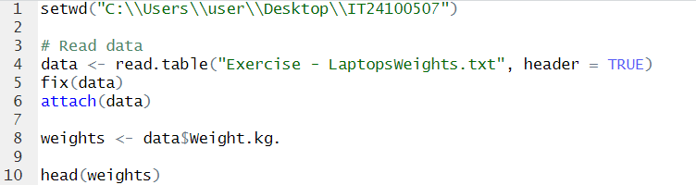

01)

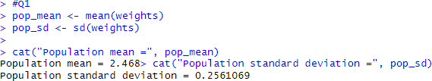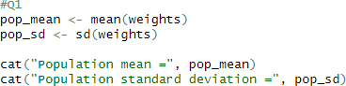

02)

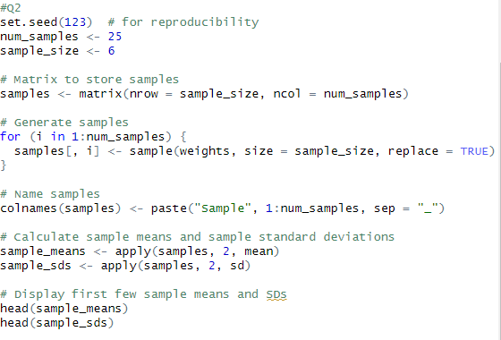

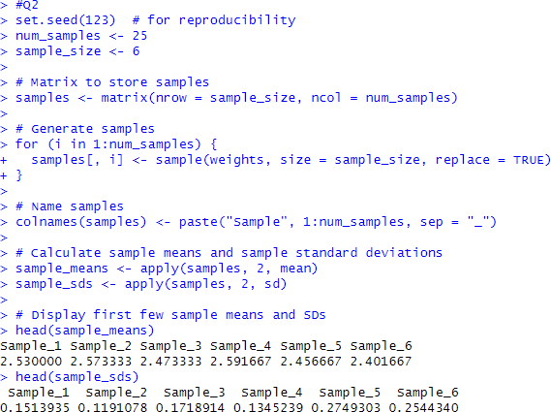

03)

